LEX PROGRAMS IN LAB

1)LEX PROGRAM TO EXECUTE CAPITAL LETTERS

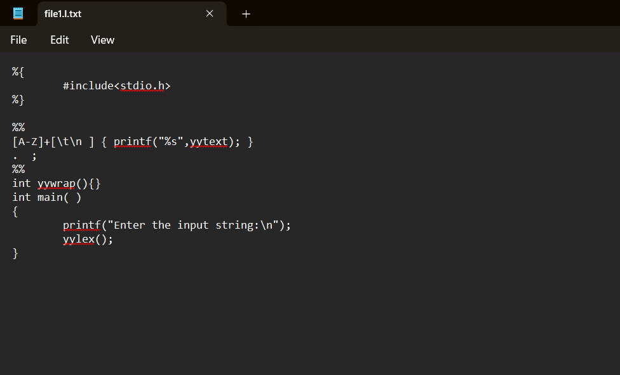

OUTPUT:

